Spring and Summer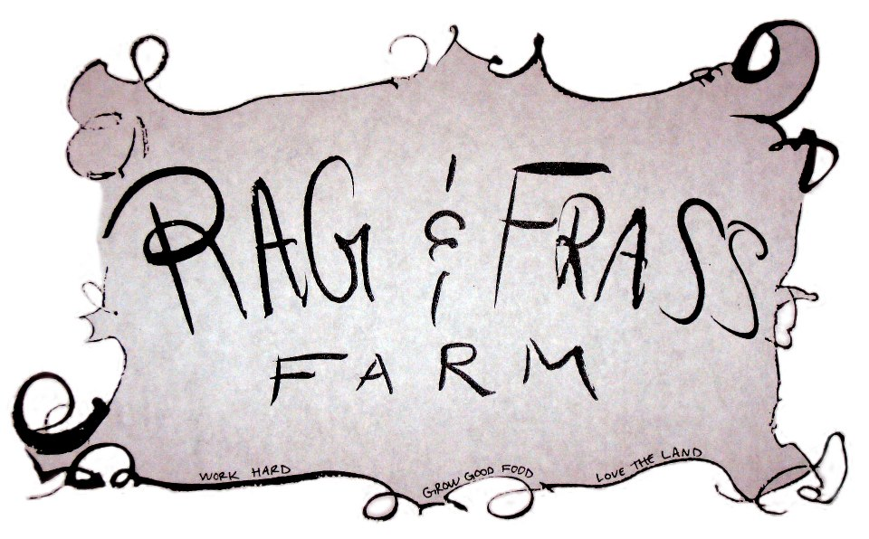2016 CSA Application
Ragandfrassfarm.com
Enclose deposit or payment with application and mail to
15176 US Hwy 80 Jeffersonville, GA 31044 or bring it to us at market!
Make checks out to Rag & Frass Farm. Cash or market tokens also accepted.

Name(s)_______________________________________________________________________________

Phone (where we can reach you)____________________________________________________________

Email Address__________________________________________________________________________

Address_______________________________________________________________________________

____________________________________________________________________________________

CSA Options and dates (circle one)
CSA Buying Club- For people who want shopping flexibility, have larger families, or who like to purchase in bulk. Shop at any of our markets or on farm and apply discount to total retail purchase. $100 for 1 year of 15% discount off market price.

and/or

CSA Box Macon- Wednesday 4pm-7 pm Mulberry Street (in Tatnall Square Park) $400 for 16 weeks ($25/week)- 4/13/16 to 7/27/16

CSA Box Milledgeville- Saturday 9am-noon Greenway Farmers Market (on River Greenway) $400 for 16 weeks ($25/week)- 4/16/16 to 7/30/16

CSA Box Jeffersonville- Thursday 3pm-6pm Pickup at Rag & Frass Farm! $400 for 16 weeks ($25/week)- 4/14/16 to 7/28/16

A $50 deposit is required to reserve a CSA Box. Full payment is due by 3/1/16.

Amount Enclosed____________________ Check #_______________Total Due_____________________

Would you like eggs automatically included in your share when available? _________________________

Favorite Veggies: _______________________________________________________________________

_____________________________________________________________________________________

Least Favorite Veggies: __________________________________________________________________

_____________________________________________________________________________________

Please sign that you have read, understand, and will comply with the CSA rules and policy:

Signature________________________________________ Date______________________

